Chapter 12, Problem 73.

For the circuit displayed in Fig. 12.74, find the wattmeter readings.

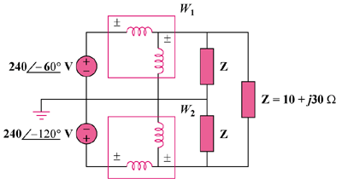

Figure 12.74
For Prob. 12.73.

